**Digital Childhood STEM Multimodality EECERA SIG 2024 Face to Face meeting**

**4th September Wednesday 17.45-18.45**

**Convenors:**

**Dr Lorna Arnott:** [**lorna.arnott@strath.ac.uk**](mailto:lorna.arnott@strath.ac.uk)

**Maria Dardanou:** [**maria.dardanou@uit.no**](mailto:maria.dardanou@uit.no)

**Dr Sarika Kewalramani:** [**skewalramani@swin.edu.au**](mailto:skewalramani@swin.edu.au)

**Agenda with meeting minutes**

1. **Welcome and Collating attendance (5 minutes)**

|  |  |  |
| --- | --- | --- |
| **Name** | **Email and name of University/workplace** | **New member (Y/N)** |
| **Uijae, Kwon** | **rhsm1028@gmail.com** | **Y** |
| **Keon-Ryeong Park** | **keonryeong@gmail.com** | **Y** |
| **Youngmi , Go** | **iamigym@sch.ac.kr** | **Y** |
| **Sukyoung, Park** | **parksk@konkuk.ac.kr** | **Y** |
| **Lena Hollenstein** | **lena.hollenstein@phsg.ch** | **Y** |
| **Olivia Benz** | **olivia.benz@phsg.ch** | **Y** |
| **Franziska Vogt** | **franziska.vogt@phsg.ch** | **Y** |
| **Jeremie Passeraub** | **jeremie.passeraub@hepl.ch** | **Y** |
| **Lennie Barblett** | **l.barblett@ecu.edu.au** | **Y** |
| **Grete Skjeggestad Meyer** | **NLA University College, Bergen, Norway**  **grete.skjeggestad.meyer@nla.no** | **N** |
| **Svitlana Holovchuk** | **NLA University College, Bergen, Norway**  **svitlana.holovchuk@nla.no** | **Y** |
| **Francesca Granone** | **University of Stavanger, Norway**  **francesca.granone@uis.no** | **N** |
| **Nadja Lebedeva** | **Dalarna University, Sweden**  **nle@du.se** | **Y** |
| **Jubilee Smith** | **jubilee.smith@scu.edu.au** | **Y** |
| **Paula Walshe** | **paula.walshe@dkit.ie** | **N** |
| **Andrea Ng** | **andreang@swin.edu.au** | **N** |
| **Mehmet Mart** | **dr.mehmetmart@gmail.com** | **N** |
| **Mustafa ciftcioglu** | **s2452324@ed.ac.uk** | **N** |
| **An Piessens** | **an.piessens@kdg.be** | **Y** |
| **Thijs Eeckhout** | **Thijs.Eeckhout@odisee.be** | **Y** |
| **Christine Jack** | **christine.jack@ncl.ac.uk** | **Y** |
| **Κayla Willemse** | **kayla.willemse@up.ac.za** | **Y** |
| **Nadia Swanepoel** | **nadia.swanepoel1@up.ac.za** | **Y** |
| **Jennifer Cutri** | **jcutri@swin.edu.au** | **Y** |
| **Anamika Devi** | **adevi@swin.edu.au** | **Y** |
| **Khaiden Dow** | [**khaiden.dow@uwa.edu.au**](mailto:khaiden.dow@uwa.edu.au)**, University of Western Australia** | **Y** |
| **Lauren Schlechte** | **laura.schlechte@uni-leipzig.de** | **Y** |
| **Olga Fotakopoulou** | **olga.fotakopoulou@bcu.ac.uk** | **N** |
| **Bin Guo** | **bin.guo.15@ucl.ac.uk** | **Y** |

**Actions from 2023 meeting series:**

1. **What members have told us so far and planning ‘active’ collaborations: Where to from here (20 minutes)**

* Individual or Group projects – update from any members/project groups
* International collaborations with similar research interests and apply funding

**Minutes:** We had 21 new members join us and the convenors suggested they reach out to them for any support needed for international collaborations. There were 3 project pitches as below.

1. **Mini research project pitch/show and tell discussions (20 minutes in total)**

Latest news on the field – members were invited to share their latest research (any Sole/Joint publications)

**Minutes:**

1. Anamika Devi, Swinburne University, Australia (Topic: current projects regarding STEM and Mursion) - Anamika and Jennifer from Swinburne University of Technology presented their STEM and technology (use of VR immersive classrooms) projects they are currently involved in their Department of Education, EC initial teacher education and in-service PD programs. Please contact [adevi@swin.edu.au](mailto:adevi@swin.edu.au) and [jcutri@swin.edu.au](mailto:jcutri@swin.edu.au) **if interested in getting involved in their mixed-methods study and having access to/adapting surveys/interview protocols for comparative/cross–cultural international study related projects.**
2. Paula Walshe, Dundalk Institute of Technology, Ireland (Topic: current PhD research - development and evaluation of a STEAM training intervention for early childhood educators) - Paula presented her PhD project and pitched for collaborations in EC STEAM teacher CPD programs). Please contact [**paula.walshe@dkit.ie**](mailto:paula.walshe@dkit.ie) **if interested in international collaborations in this area.**
3. Olga Fotakopoulou, College of Psychology, Birmingham City University, UK (Topic: Scientist project)

Olga pitched for the Draw a Scientist study project that has currently been conducted in UK, Greece, Norway and Australian museum/community settings. Please contact [**olga.fotakopoulou@bcu.ac.uk**](mailto:olga.fotakopoulou@bcu.ac.uk) **if interested in international collaborations in this area.**

1. **Members celebrated below good news publications/book chapter/special issue calls (10 minutes)**

**Minutes:**

1. Grete Skjeggestad Meyer - presented the Norwegian research anthology (2024): “Danning i digitale praksiser. Digital danning i barnehage, skole, hjem og fritid”

(= Bildung in a digital contexts. Digital Bildung in Early Childhood Education, School, Home and Spare-time.)

1. Paula Walshe - shared information on recent book publication “Full STEAM Ahead - Science, Technology, Engineering, The Arts and Maths in Early Childhood Education”.
2. Book chapter call for EECERA series Book Title: **Pedagogy, Curriculum & Professionalism: International perspectives in early childhood initial teacher education** (Editors – Dr Anamika Devi, Dr Jennifer Cutri, Dr Sarika Kewalramani) – **Sarika has emailed the book chapter call to all SIG Members. Please circulate amongst your network and those who might be interested.**

**5. Wrap up and celebration of SIG related outputs (5 minutes)**

1. Book (published 4th December 2023): Science, Technology, Engineering, Arts and Mathematics (STEAM) Education in the Early Years: Achieving the Sustainable Development Goals - Sarika (one of the book editors) launched the book with EECERA Praxis series editors Prof Chris Pascal and Prof Tony Bertram during the conference exhibition session.

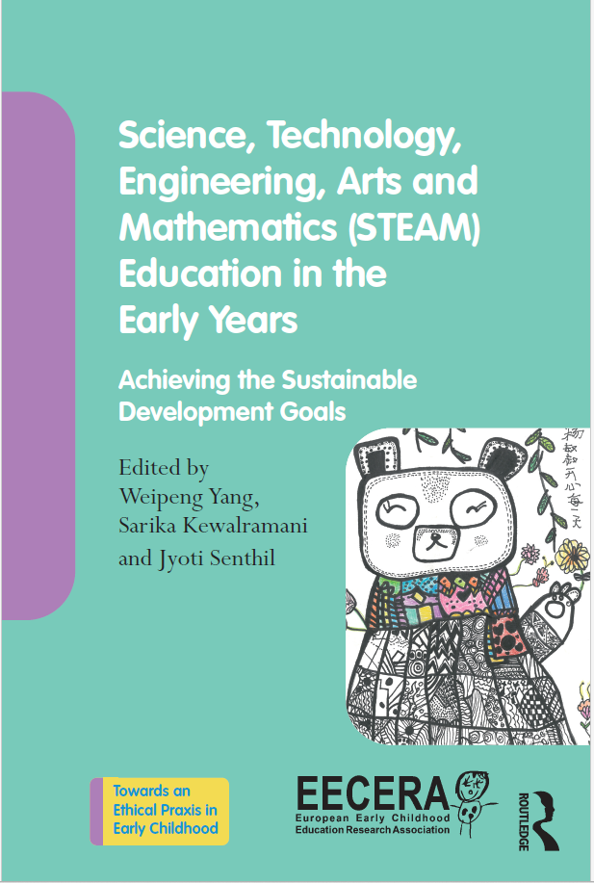

**6. Next meeting online via Zoom (TBA date/time)**

**Discussion Topic will be AI in early childhood education**

**Thank you for all your inputs! Please email us and each other with any further ideas for leading projects/funding applications/papers.**

**Kind regards, Sarika, Maria and Lorna**